NAME: MUHAMMAD ISTAFA MALIK

DEPARTMENT: BS(CS) 19 A

ROLL NO.19P-0033

DATE : 19/9/2019

ASSIGNMENT 1

PROGRAMMING FUNDAMENTALS

PROFESSOR: MUHAMMAD SHOAIB KHAN

Task 1:

Write a program which takes input 2 numbers and store their values in 2 variables num1 and num2 respectively, swap values of the two variable. Output the value of num1 and num2 before and after swapping their values and the sum of the two values on console.

Solution:

#include <iostream>

using namespace std;

int main()

{

int num1,num2,num3,sum;

cout<< "Enter first number : ";

cin>> num1;

cout<< "Enter second number : ";

cin>>num2;

cout<< "Number before swaping ";

cout<< num1 <<" "<< num2<<endl;

num3 =num1;

num1 =num2;

num2 =num3;

cout<< "After swaping number is : "<<num1<<" "<<num2<<endl;

sum = num1 + num2;

cout<< "The sum of num1 and num2 is "<<sum<<endl;

return 0;

}

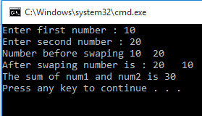

Task 2:

Write a program that takes input 1 number and changes its sign. You should output the number with the opposite sign on console.

e.g. input: 12 input: -12 output: -12 output: 12

SOLUTION:

#include<iostream>

using namespace std;

int main()

{

int Number;

cout<< "Enter your Number"<<endl;

cin>>Number;

cout<<"Output of given number is "<<-Number<<endl;

return 0;

}

FOR NEGATIVE FOR POSITIVE

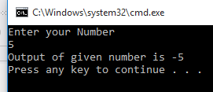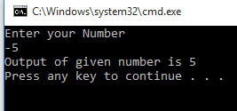

Task 3:

Write a program that takes 5 numbers as an input. Shows their average on console.

SOLUTION:

#include <iostream>

using namespace std;

int main ()

{

int total,Number;

cout<< "enter Number first : ";

cin>>Number;

total = Number;

cout<< "enter Number second : ";

cin>>Number;

total = total + Number ;

cout<< "enter Number third : ";

cin>>Number;

total = total + Number;

cout<< "enter Number fourth : ";

cin>>Number;

total = total + Number;

cout<< "enter Number fifth : ";

cin>>Number;

total = total + Number;

total = total/5;

cout<< "average of 5 values is : "<<total<<endl;

return 0;

}

